**Milestone 2 - Domain Modeling Group 06**

Ruud van Bakel - 2614457

Lieke Venneker - 2623353

Janus Jansen - 2623707

1. a description of the domain and scope of the ontology, as determined by the application (100-200 words)

The domain is houseplants. The ontology will be used by people who are looking to purchase plants, and need information about plants. The ontology will help them find the perfect plant for them, by giving options to select which will lead to the display of different plants that fit the requirements of the user of the application.

1. a description of the methodology that is used in the construction of the ontology (100-200 words)

For making the ontology, the first step was thinking about what could be useful when a person wants to purchase a plant. This way the classes light requirements, price range, leaf colour and water requirements were added to the ontology. A few instances, plants, were added to fill the ontology. This way the base for the ontology was built.

The reuse of ontologies from external sources was quite a challenge, since there are not a lot of plant-ontologies that satisfies the needs for the application. In the end a few small parts from other ontologies, to satisfy the restriction of reusing ontologies.

1. a conceptualization of the domain (concepts, relations) described, discussed and depicted in a drawing. The conceptualization should encompass more than 15 classes and at least 5 properties (200-300 words)

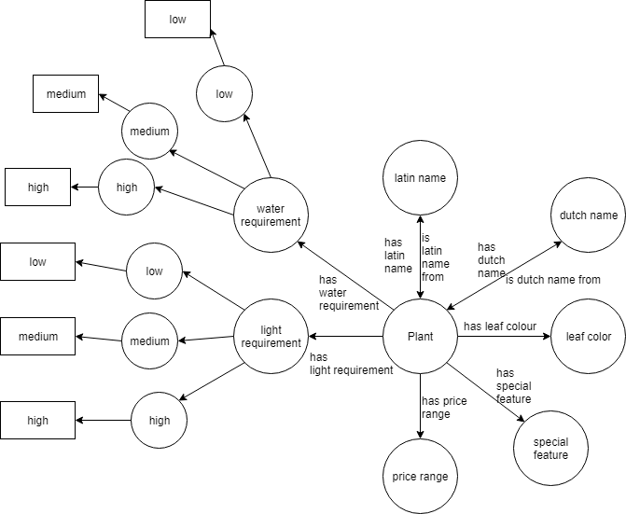

As base of the ontology the class plant was chosen, since the ontology revolves around choosing plants to buy. Because the application will help with the purchase of plants, the price range was added. For the user it would also be useful to know how the plant needs to be cared for, which include the light requirement (low, medium, high) and the water requirement (low, medium, high). Because the plants are houseplants, users might also find it interesting to know the leaf color of the plant. For extra information the latin and dutch name were added to the ontology, which means that the plant will be found when either of those names are used.

1. an ontology that explicitly represents the conceptualization in OWL. Use at least 5 class restrictions. The ontology should reuse at least 3 existing vocabularies or ontologies. Describe the ontology, and the decisions made (200-300 words).  
   Also provide the ontology as a separate Turtle file.

The application uses dbpedia as an existing vocabulary. It uses the data from the depiction, abstract and binomial names and later perhaps more. we also use an ontology from the plant ontology consortium.

1. the ontology should produce meaningful inferences that are essential for the application. This should be evidenced by a screenshot of e.g. Protege reasoning results. Describe the inferences (100-500 words) (NB: For the final report: inferences should be on the external data)

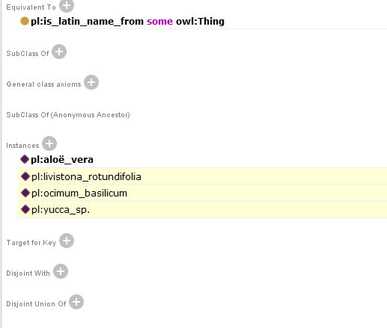

Because the names are in different languages (Latin, English and Dutch), it is inferred that the names belong in the corresponding classes. Here it can be seen that the latin names of the fan palm, the basil and the dracaena are inferred.

1. Combine this with a revised version of milestone 1

No feedback was given yet, so there is no revised version of milestone 1.